**Cloud Computing Tutorial for Beginners**

## What is Cloud Computing?

Cloud Computing can be defined as delivering computing power( CPU, RAM, Network Speeds, Storage OS software) a service over a network (usually on the internet) rather than physically having the computing resources at the customer location.

**Example:**AWS, Azure, Google Cloud

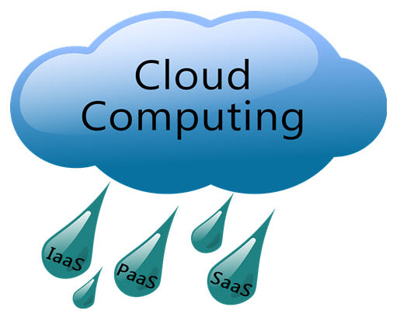

Let’s learn Cloud computing with an example -

Whenever you travel through a bus or train, you take a ticket for your destination and hold back to your seat till you reach your destination. Likewise other passengers also takes ticket and travel in the same bus with you and it hardly bothers you where they go. When your stop comes you get off the bus thanking the driver. Cloud computing is just like that bus, carrying data and information for different users and allows to use its service with minimal cost.

**In this tutorial, you will learn**

* [Types of Clouds](https://www.guru99.com/cloud-computing-for-beginners.html#1)
* [Cloud Computing Services](https://www.guru99.com/cloud-computing-for-beginners.html#2)
* [Cloud Computing Architecture](https://www.guru99.com/cloud-computing-for-beginners.html#3)
* [Virtualization and Cloud Computing:](https://www.guru99.com/cloud-computing-for-beginners.html#4)
* [Grid Computing Vs Cloud Computing](https://www.guru99.com/cloud-computing-for-beginners.html#5)
* [Grid Computing and Utility Computing](https://www.guru99.com/cloud-computing-for-beginners.html#6)
* [Security concerns and proposed security model for future cloud computing](https://www.guru99.com/cloud-computing-for-beginners.html#7)
* [Privacy Concern](https://www.guru99.com/cloud-computing-for-beginners.html#8)
* [Case-Study of Cloud Computing- Royal Mail](https://www.guru99.com/cloud-computing-for-beginners.html#9)

## Why the Name Cloud?

The term “Cloud” came from a network design that was used by network engineers to represent the location of various network devices and there inter-connection.  The shape of this network design was like a cloud.

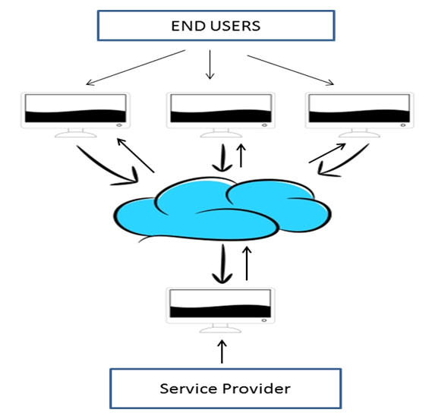

## Why Cloud Computing?

With increase in computer and Mobile user’s, data storage has become a priority in all fields. Large and small scale businesses today thrive on their data & they spent a huge amount of money to maintain this data. It requires a strong IT support and a storage hub. Not all businesses can afford high cost of in-house IT infrastructure and back up support services. For them Cloud Computing is a cheaper solution. Perhaps its efficiency in storing data, computation and less maintenance cost has succeeded to attract even bigger businesses as well.

Cloud computing decreases the hardware and software demand from the user’s side. The only thing that user must be able to run is the cloud computing systems interface software, which can be as simple as Web browser, and the Cloud network takes care of the rest. We all have experienced cloud computing at some instant of time, some of the popular cloud services we have used or we are still using are mail services like gmail, hotmail or yahoo etc.

While accessing e-mail service our data is stored on cloud server and not on our computer. The technology and infrastructure behind the cloud is invisible. It is less important whether cloud services are based on HTTP, XML, Ruby,[PHP](https://www.guru99.com/php-tutorials.html)or other specific technologies as far as it is user friendly and functional. An individual user can connect to cloud system from his/her own devices like desktop, laptop or mobile

Cloud computing harnesses small business effectively having limited resources, it gives small businesses access to the technologies that previously were out of their reach.  Cloud computing helps small businesses to convert their maintenance cost into profit. Let’s see how?

In an in-house IT server, you have to pay a lot of attention and ensure that there are no flaws into the system so that it runs smoothly. And in case of any technical glitch you are completely responsible; it will seek a lot of attention, time and money for repair. Whereas, in cloud computing, the service provider takes the complete responsibility of the complication and the technical faults.

## Benefits of Cloud Computing

The potential for cost saving is the major reason of cloud services adoption by many organizations.  Cloud computing gives the freedom to use services as per the requirement and pay only for what you use. Due to cloud computing it has become possible to run IT operations as a outsourced unit without much in-house resources.

Following are the benefits of cloud computing:

1. Lower IT infrastructure and computer costs for users
2. Improved performance
3. Fewer Maintenance issues
4. Instant software updates
5. Improved compatibility between Operating systems
6. Backup and recovery
7. Performance and Scalability
8. Increased storage capacity
9. Increase data safety

## Types of Clouds

There are four different cloud models that you can subscribe according to business needs:

[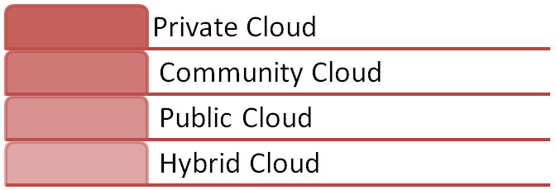](https://www.guru99.com/images/blog_image/cloud_computing_3.jpg)

1. **Private Cloud:**Here**,**computing resources are deployed for one particular organization.  This method is more used for intra-business interactions.  Where the computing resources can be governed, owned and operated by the same organization.
2. **Community Cloud:**Here**,**computing resources are provided for a community and organizations.
3. **Public Cloud:**This type of cloud is used usually for B2C (Business to Consumer) type interactions.  Here the computing resource is owned, governed and operated by government, an academic or business organization.
4. **Hybrid Cloud:**This type of cloud can be used for both type of interactions -  B2B (Business to Business) or B2C ( Business to Consumer). This deployment method is called hybrid cloud as the computing resources are bound together by different clouds.

## Cloud Computing Services

The three major Cloud Computing Offerings are

* **Software as a Service (SaaS)**
* **Platform as a Service (PaaS)**
* **Infrastructure as a Service (IaaS)**

Different business use some or all of these components according to their requirement.

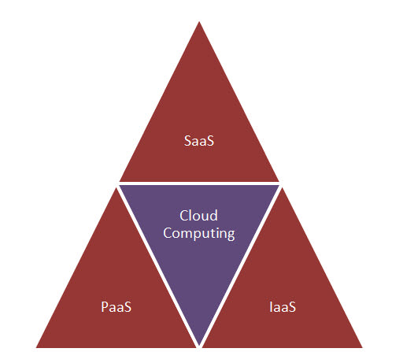

## SaaS (Software as a Service)

SaaS or software as a service is a software distribution model in which applications are hosted by a vendor or service provider and made available to customers over a network (internet). SaaS is becoming an increasingly prevalent delivery model as underlying technologies that supports **Service Oriented Architecture (SOA) or Web Services**. Through internet this service is available to users anywhere in the world.

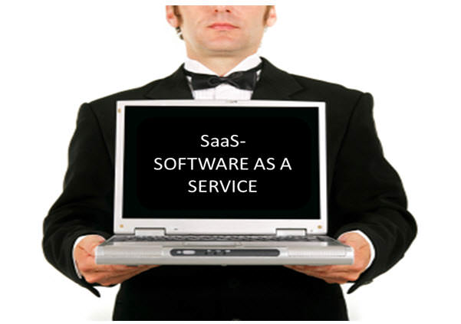

Traditionaly, software application needed to be purchased upfront &then installed it onto your computer. SaaS users on the other hand, instead of purchasing the software subscribes to it, usually on monthly basisvia internet.

Anyone who needs an access to a particular piece of software can be subscribe as a user, whether it is one or two people or every thousands of employees in a corporation. SaaS is compatible with all internet enabled devices.

Many important tasks like accounting, sales, invoicing and planning all can be performed using SaaS.

## PaaS (Platform as a Service)

Platform as a service, is referred as PaaS, it provides a platform and environment to allow developers to build applications and services. This service is hosted in the cloud and accessed by the users via internet.

To understand in a simple terms, let compare this with painting a picture, where you are provided with paint colors, different paint brushes and paper by your school teacher and you just have to draw a beautiful picture using those tools.



PaaS services are constantly updated & new features added. Software developers, web developers and business can benefit from PaaS. It provides platform to support application development. It includes software support and management services, storage, networking, deploying, testing, collaborating, hosting and maintaining applications.

## IaaS (Infrastructure as a Service)

IaaS (Infrastructure As A Service) is one of the fundamental service model of cloud computing alongside PaaS( Platform as a Service). It provides access to computing resources in a virtualized environment “the cloud” on internet.  It provides computing infrastructure like virtual server space, network connections, bandwidth, load balancers and IP addresses. The pool of hardware resource is extracted from multiple servers and networks usually distributed across numerous data centers.  This provides redundancy and reliability to IaaS.

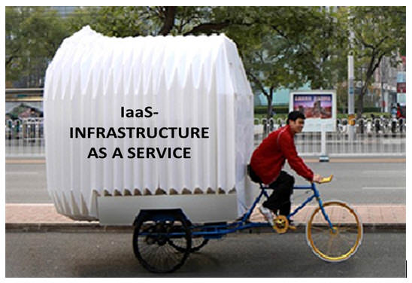

**IaaS(Infrastructure as a service)**is a complete package for computing. For small scale businesses who are looking for cutting cost on IT infrastructure, IaaS is one of the solutions. Annually a lot of money is spent in maintenance and buying new components like hard-drives, network connections, external storage device etc. which a business owner could have saved for other expenses by using IaaS.

## What is Cloud Computing Architecture?

Let’s have a look into Cloud Computing and see what Cloud Computing is made of. Cloud computing comprises of two components front end and back end.  Front end consist client part of cloud computing system. It comprise of interfaces and applications that are required to access the cloud computing platform.

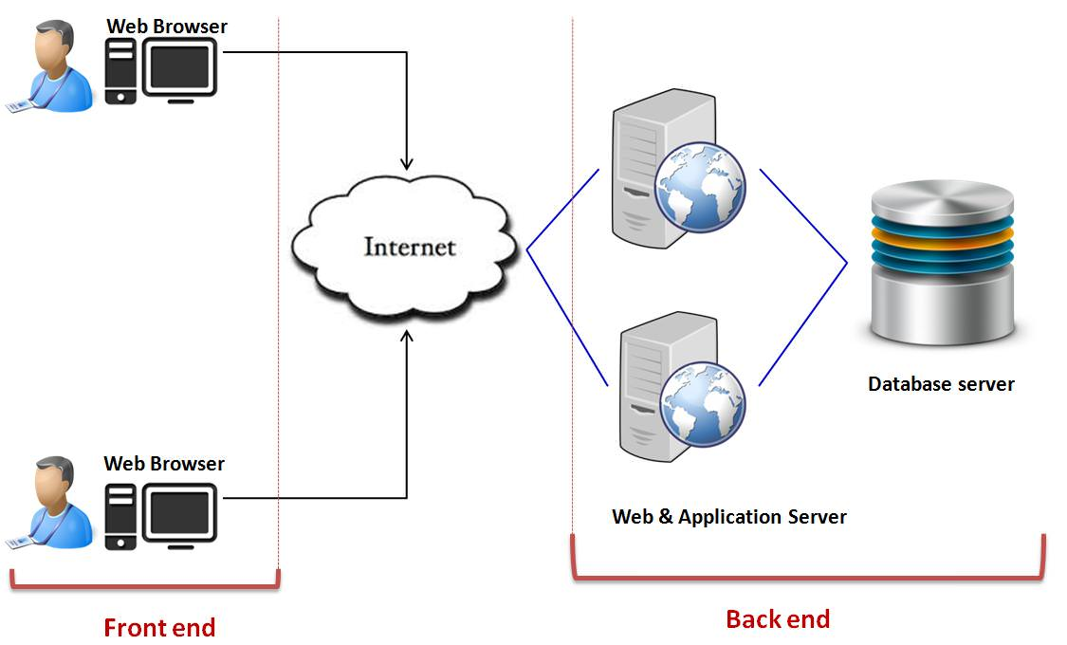

While back end refers to the cloud itself, it comprises of the resources that are required for cloud computing services. It consists of virtual machines, servers, data storage, security mechanism etc. It is under providers control.

Cloud computing distributes the file system that spreads over multiple hard disks and machines. Data is never stored in one place only and in case one unit fails the other will take over automatically. The user disk space is allocated on the distributed file system, while another important component is algorithm for resource allocation. Cloud computing is a strong distributed environment and it heavily depends upon strong algorithm.

## Virtualization and Cloud Computing

The main enabling technology for Cloud Computing is Virtualization. Virtualization is a partitioning of single physical server into multiple logical servers.  Once the physical server is divided, each logical server behaves like a physical server and can run an operating system and applications independently.  Many popular companies’s like VmWare and Microsoft provide virtualization services, where instead of using your personal PC for storage and computation, you use their virtual server. They are fast, cost-effective and less time consuming.

For software developers and testers virtualization comes very handy, as it allows developer to write code that runs in many different environments and more importantly to test that code.

Virtualization is mainly used for three main purposes **1) Network Virtualization 2) Server Virtualization  3) Storage Virtualization**

Network Virtualization**:**It is a method of combining the available resources in a network by splitting up the available bandwidth into channels, each of which is independent from the others and each channel is independent of others and can be assigned to a specific server or device in real time.

Storage Virtualization: It is the pooling of physical storage from multiple network storage devices into what appears to be a single storage device that is managed from a central console. Storage virtualization is commonly used in storage area networks (SANs).

Server Virtualization: Server virtualization is the masking of server resources like processors, RAM, operating system etc, from server users. The intention of server virtualization is to increase the resource sharing and reduce the burden and complexity of computation from users.

Virtualization is the key to unlock the Cloud system, what makes virtualization so important for the cloud is that it decouples the software from the hardware. For example, PC’s can use virtual memory to borrow extra memory from the hard disk. Usually hard disk has a lot more space than memory. Although virtual disks are slower than real memory, if managed properly the substitution works perfectly. Likewise, there is software which can imitate an entire computer, which means 1 computer can perform the functions equals to 20 computers.

## Grid Computing Vs Cloud Computing

When we switch on the fan or any electric device, we are less concern about the power supply from where it comes and how it is generated. The power supply or electricity that we receives at our home travels through a chain of network, which includes power stations, transformers, power lines and transmission stations. These components together make a ‘Power Grid’. Likewise, ‘Grid Computing’ is an infrastructure that links computing resources such as PCs, servers, workstations and storage elements and provides the mechanism required to access them.

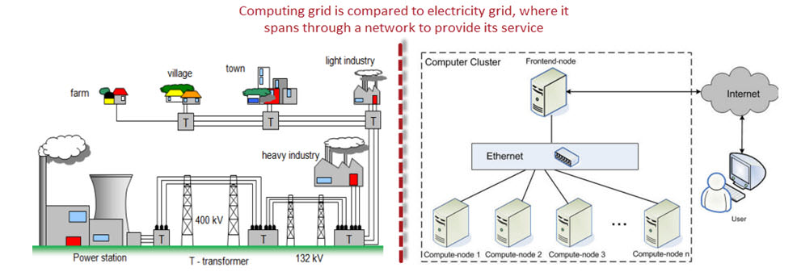

Grid Computing is a middle ware to co-ordinate disparate IT resources across a network, allowing them to function as whole. It is more often used in scientific research and in universities for educational purpose. For example, a group of architect students working on a different project requires a specific designing tool and a software for designing purpose but only couple of them got access to this designing tool, the problem is how they can make this tool available to rest of the students. To make available for other students they will put this designing tool on campus network, now the grid will connect all these computers in campus network and allow student to use designing tool required for their project from anywhere.

Cloud computing and Grid computing is often confused, though there functions are almost similar there approach for their functionality is different.  Let see how they operate-

|  |  |
| --- | --- |
| **Cloud Computing** | **Grid Computing** |
| * Cloud computing works more as a service provider for utilizing computer resource | * Grid computing uses the available resource and interconnected computer systems to accomplish a common goal |
| * Cloud computing is a centralized model | * Grid computing is a decentralized model, where the computation could occur over many administrative model |
| * Cloud is a collection of computers usually owned by a single party. | * A grid is a collection of computers which is owned by a multiple parties in multiple locations and connected together so that users can share the combined power of resources |
| * Cloud offers more services all most all the services like web hosting, DB (Data Base) support and much more | * Grid provides limited services |
| * Cloud computing is typically provided within a single organization (eg : Amazon) | * Grid computing federates the resources located within different organization. |

## Utility Computing Vs Cloud Computing

In our previous conversation in “Grid Computing” we have seen how electricity is supplied to our house, also we do know that to keep electricity supply we have to pay the bill. Utility Computing is just like that, we use electricity at home as per our requirement and pay the bill accordingly likewise you will use the services for the computing and pay as per the use this is known as ‘Utility computing’. Utility computing is a good source for small scale usage, it can be done in any server environment and requires Cloud Computing.



Utility computing is the process of providing service through an on-demand, pay per use billing method.  The customer or client has access to a virtually unlimited supply of computing solutions over a virtual private network or over the internet, which can be sourced and used whenever it’s required.  Based on the concept of utility computing , grid computing, cloud computing and managed IT services are based.

Through utility computing small businesses with limited budget can easily use software like CRM (Customer Relationship Management) without investing heavily on infrastructure to maintain their clientele base.

|  |  |
| --- | --- |
| **Utility Computing** | **Cloud Computing** |
| * Utility computing refers to the ability to charge the offered services, and charge customers for exact usage | * Cloud Computing also works like utility computing, you pay only for what you use but Cloud Computing might be cheaper, as such, Cloud based app can be up and running in days or weeks. |
| * Utility computing users want to be in control of the geographical location of the infrastructure | * In cloud computing, provider is in complete control of cloud computing services and infrastructure |
| * Utility computing is more favorable when performance and selection infrastructure is critical | * Cloud computing is great and easy to use when the selection infrastructure and performance is not critical |
| * Utility computing is a good choice for less resource demanding | * Cloud computing is a good choice for high resource demanding |
| * Utility computing refers to a business model | * Cloud computing refers to the underlying IT architecture |

## Security concerns for Cloud Computing

While using cloud computing, the major issue that concerns the users is about its security.

One concern is that cloud providers themselves may have access to customer’s unencrypted data- whether it’s on disk, in memory or transmitted over the network.

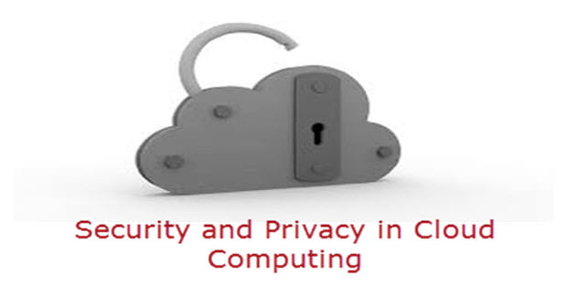

Some countries government may decide to search through data without necessarily notifying the data owner, depending on where the data resides, which is not appreciated and is considered as a privacy breach (Example [Prism](http://en.wikipedia.org/wiki/PRISM_(surveillance_program)) Program by USA).

To provide security for systems, networks and data cloud computing service providers have joined hands with TCG ( Trusted Computing Group) which is non-profit organization which regularly releases a set of specifications to secure hardware, create self-encrypting drives and improve network security.  It protects the data from root kits and malware.

As computing has expanded to different devices like hard disk drives and mobile phones, TCG has extended the security measures to include these devices. It provides ability to create a unified data protection policy across all clouds.

Some of the trusted cloud services are Amazon, Box.net, Gmail and many others.

## Privacy Concern & Cloud Computing

Privacy present a strong barrier for users to adapt into Cloud Computing systems

There are certain measures which can improve privacy in cloud computing.

1. The administrative staff of the cloud computing service could theoretically monitor the data moving in memory before it is stored in disk.To keep the confidentiality of a data, administrative and legal controls should prevent this from happening.
2. The other way for increasing the privacy is to keep the data encrypted at the cloud storage site, preventing unauthorized access through the internet; even cloud vendor can’t access the data either.

## Case-Study of Cloud Computing- Royal Mail

* **Subject of Case-Study:**Using Cloud Computing for effective communication among staff.
* **Reason for using Cloud Computing:**Reducing the cost made after communication for 28,000 employees and to provide advance features and interface of e-mail services to their employees.

Royal mail group, a postal service in U.K, is the only government organization in U.K that serves over 24 million customers through its 12000 post offices and 3000 separate processing sites.  Its logistics systems and parcel-force worldwide handles around 404 million parcel a year. And to do this they need an effective communicative medium. They have recognized the advantage of Cloud Computing and implemented it to their system. It has shown an outstanding performance in inter-communication.

Before moving on to Cloud system, the organization was struggling with the out-of-date software, and due to which the operational efficiency was getting compromised.  As soon as the organization switched on to Cloud System, 28000 employees were supplied with their new collaboration suite, giving them access to tools such as instant messaging and presence awareness.  The employees got more storage place than on local server. The employees became much more productive.

Looking to the success of Cloud Computing in e-mail services and communication .The second strategic move of Royal Mail Group, was to migrating from physical servers to virtual servers, upto 400 servers to create a private cloud based on Microsoft hyper V. This would give a fresh look and additional space to their employees desktop and also provides latest modern exchange environment.

The hyper V project by RMG’s (Royal Mail Group) is estimated to save around 1.8 million pound for them in future and will increase the efficiency of the organization’s internal IT system.

# Advantages and Disadvantages Of Cloud Computing

## What is Cloud Computing?

Cloud computing is a term referred to storing and accessing data over the internet. It doesn't store any data on the hard disk of your personal computer. In cloud computing, you can access data from a remote server.

## Advantages of Cloud Computing

Here, are important benefits for using Cloud computing in

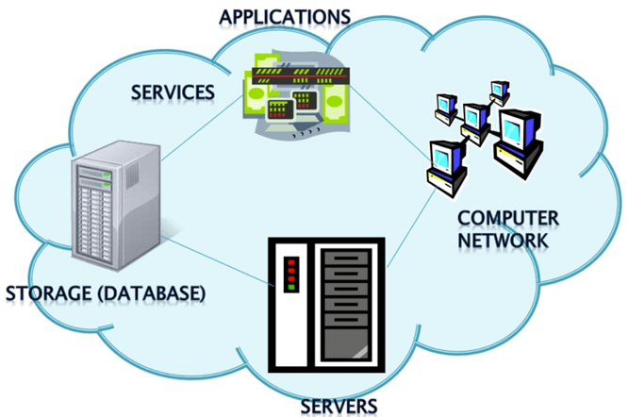

### Cost Savings

Cost saving is the biggest benefit of cloud computing. It helps you to save substantial capital cost as it does not need any physical hardware investments. Also, you do not need trained personnel to maintain the hardware. The buying and managing of equipment is done by the cloud service provider.

### Strategic edge

Cloud computing offers a competitive edge over your competitors. It helps you to access the latest and applications any time without spending your time and money on installations.

### High Speed

Cloud computing allows you to deploy your service quickly in fewer clicks. This faster deployment allows you to get the resources required for your system within fewer minutes.

### Back-up and restore data

Once the data is stored in a Cloud, it is easier to get the back-up and recovery of that, which is otherwise very time taking process on-premise.

### Automatic Software Integration

In the cloud, software integration is something that occurs automatically. Therefore, you don't need to take additional efforts to customize and integrate your applications as per your preferences.

### Reliability

Reliability is one of the biggest pluses of cloud computing. You can always get instantly updated about the changes.

### Mobility

Employees who are working on the premises or at the remote locations can easily access all the could services. All they need is an Internet connectivity.

### Unlimited storage capacity

The cloud offers almost limitless storage capacity. At any time you can quickly expand your storage capacity with very nominal monthly fees.

### Collaboration

The cloud computing platform helps employees who are located in different geographies to collaborate in a highly convenient and secure manner.

### Quick Deployment

Last but not least, cloud computing gives you the advantage of rapid deployment. So, when you decide to use the cloud, your entire system can be fully functional in very few minutes. Although, the amount of time taken depends on what kind of technologies are used in your business.

### Other Important Benefits

Apart from the above, some other advantages of cloud computing are:

* On-Demand Self-service
* Multi-tenancy
* Offers Resilient Computing
* Fast and effective virtualization
* Provide you low-cost software
* Offers advanced online security
* Location and Device Independence
* Always available, and scales automatically to adjust to the increase in demand
* Allows pay-per-use
* Web-based control & interfaces
* API Access available.

## Disadvantages of Cloud Computing

Here, are significant challenges of using Cloud Computing:

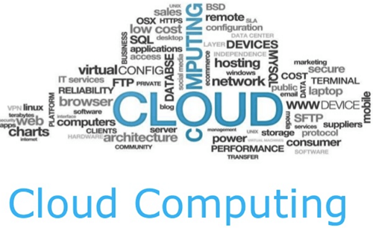

### Performance Can Vary

When you are working in a cloud environment, your application is running on the server which simultaneously provides resources to other businesses. Any greedy behavior or DDOS attack on your tenant could affect the performance of your shared resource.

### Technical Issues

Cloud technology is always prone to an outage and other technical issues. Even, the best cloud service provider companies may face this type of trouble despite maintaining high standards of maintenance.

### Security Threat in the Cloud

Another drawback while working with cloud computing services is security risk. Before adopting cloud technology, you should be well aware of the fact that you will be sharing all your company's sensitive information to a third-party cloud computing service provider. Hackers might access this information.

### Downtime

Downtime should also be considered while working with cloud computing. That's because your cloud provider may face power loss, low internet connectivity, service maintenance, etc.

### Internet Connectivity

Good Internet connectivity is a must in cloud computing. You can't access cloud without an internet connection. Moreover, you don't have any other way to gather data from the cloud.

### Lower Bandwidth

Many cloud storage service providers limit bandwidth usage of their users. So, in case if your organization surpasses the given allowance, the additional charges could be significantly costly

### Lacks of Support

Cloud Computing companies fail to provide proper support to the customers. Moreover, they want their user to depend on FAQs or online help, which can be a tedious job for non-technical persons.

## Conclusion:

Despite all the pro and cons, we can't deny the fact that Cloud Computing is the fastest growing part of network-based computing. It offers a great advantage to customers of all sizes: simple users, developers, enterprises and all types of organizations. So, this technology here to stay for a long time.

# Top 21 Cloud Computing Service Provider Companies in 2019

Cloud Computing Services are vendors which provide Information Technology (IT) as a service over the Internet. Cloud computing is a term which is used for storing and accessing data over the internet. It doesn't store any data on the hard disk of your PC. Cloud computing helps you to access your data from a remote server.

Cloud computing services range from full applications and development platforms to servers, storage, and virtual desktops. There's are various types of cloud computing services are available in the market.

Here, is a curated list of best 21 Cloud Service Tools.

### 1) [Amazon Web Services](https://aws.amazon.com/)

[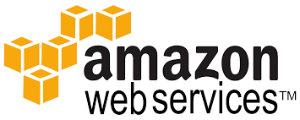](https://aws.amazon.com/)

[AWS](https://aws.amazon.com/) is Amazon's cloud web hosting platform which offers fast, flexible, reliable and cost-effective solutions. It offers a service in the form of building block which can be used to create and deploy any kind of application in the cloud. It is the most popular as it was the first to enter the cloud computing space.

**Features:**

* Easy sign-up process
* Fast Deployments
* Allows easy management of add or remove capacity
* Access to effectively limitless capacity
* Centralized Billing and management
* Offers Hybrid Capabilities and per hour billing

### 2) [Kamatera](https://bit.ly/2VEnOPQ)

[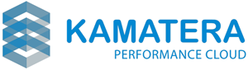](https://bit.ly/2VEnOPQ)

A cloud server tool developed by [Kamatera](https://bit.ly/2VEnOPQ) is very much similar to a physical server. It operated in a virtual infrastructure cloud, making it highly flexible and cost-effective. This cloud server pricing is based on pay as you use model a standard in the industry.

**Features:**

* 13 Data Centers across four continents for ultimate performance and availability
* Customized and Tailored Made VPS Hosting to fit your needs
* Scalability: Allows you to quickly add load balancers, firewalls, private networks and apps such as: pfSense, Docker, CPanel, Drupal, Jenkins, WordPress, Magento, node.JS and many more.
* All SSDs with UNLIMITED TRAFFIC. 99.95% Up-Time Guaranteed
* Scale across hundreds of servers in seconds
* Billing options – Per Month or Per Day
* 24/7/365 Tech Human Support
* 30 Day Free Trial to test the services

### 3) [Cloudways](https://bit.ly/35ugvur)

[](https://bit.ly/35ugvur)

[Cloudways](https://bit.ly/35ugvur) provides managed cloud hosting to agencies, stores, and SMBs. The platform has partnered with top cloud providers including AWS, Google Cloud, DigitalOcean, Vultr and Linode. Experience the freedom to build, deploy and manage applications including PHP, Laravel, WordPress, and Magento without requiring any knowledge of cloud server management. Cloudways users can focus on business growth without worrying about the technical complexities of server management, security, and maintenance.

**Popular features include:**

* PHP 7 Ready Servers
* Simple 1-Click App Installation
* Pre-configured PHP-FPM and Redis
* Free SSL Certificates
* Automated Backups
* Staging Environment
* 24/7/365 Support

### 4) [DigtialOcean](https://bit.ly/2YDemsK)

[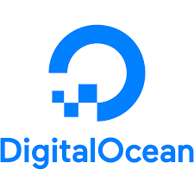](https://bit.ly/2YDemsK)

[Digitalocean's](https://bit.ly/2YDemsK) droplet is a scalable computer service. It is more than just virtual machines. This cloud platform offers add-on storage, security, and monitoring capabilities to run production applications easily.

**Features:**

* Allows you to deploy your custom image, one-click app, or standard distribution
* You can deploy Droplets and get a reliable connection and flat pricing across 8 data center regions
* Option to select Standard Plans or Performance Plans according to your business needs

### 5) [Rackspace](https://bit.ly/2JWR7Wq)

[](https://bit.ly/2JWR7Wq)

[Rackspace](https://bit.ly/2JWR7Wq) is another useful cloud computer service tool. It offers services like hosting web applications, cloud files, cloud backup, database, and cloud server, etc.

**Features:**

* Fast-migrating to the Cloud
* Helps you to prepare your business for the worst-case scenario
* Work on pay as you go model, so you are charged base on your usage
* It helps you to use a combination of solid-state drives and hard drives to deliver high performance

### 6) [MassiveGrid](https://bit.ly/2w9MBvI)

[](https://bit.ly/2w9MBvI)

[MassiveGrid](https://bit.ly/2w9MBvI) offers Virtual and Dedicated Private Clouds. With Virtual Private Clouds, helps users to have the flexibility to manage their resources in their environment according to their business needs.

**Features:**

* Offers fast & reliable Network Infrastructure
* Private cloud clients a secure web control panel, it can be used 24x7x365 to manage their clouds
* Offers high availability services with building a state of the art infrastructure
* Extremely Fast and dedicated Hardware

### 7) [Alibaba Cloud](https://bit.ly/2WcbLJ0)

[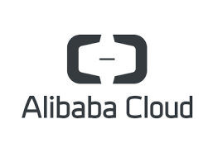](https://bit.ly/2WcbLJ0)

[Alibaba](https://bit.ly/2WcbLJ0) is the largest Chinese cloud computing company. It is a new platform which created a global footprint with over 1500 CDN Nodes worldwide of 19 regions and 56 availability zones across more than 200 countries.

**Features:**

* Helps you to achieve faster results
* Helps you to protect and backup your data
* Full management permissions and multiple management methods
* Highly stable applications and reliable data storage

### 8) [LiquidWeb](https://bit.ly/2L4pStw)

[](https://bit.ly/2L4pStw)

[The liquid web](https://bit.ly/2L4pStw) offers cloud Sites which is a managed hosting platform which offers creatives freedom to build and launch websites without the need to learn cPanel or server management.

**Features:**

* It allows you to manage your sites quickly and effortlessly
* Host Unlimited Sites & Apps with a single Account
* Not require any server management skill
* The tool can easily be integrated with WordPress, Drupal, Joomla, etc.

### 9) Microsoft Azure

[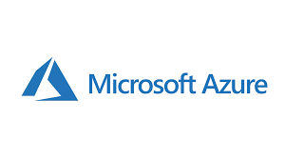](https://www.guru99.com/images/1/030119_1316_Top21CloudC3.png)

Azure is a cloud computing platform which is launched by Microsoft in February 2010. This open source and flexible cloud platform which helps in development, data storage, service management & hosting solutions.

**Features:**

* Windows Azure offers the most effective solution for your data needs
* Provides scalability, flexibility, and cost-effectiveness
* Offers consistency across clouds with familiar tools and resources
* Allow you to scale your IT resources up and down according to your business needs

**Download link:** <https://azure.microsoft.com/en-in/>

### 10) Google Cloud Platform

[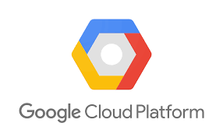](https://www.guru99.com/images/1/030119_1316_Top21CloudC4.png)

Google Cloud is a set of solution and products which includes GCP & G suite. It helps you to solve all kind of business challenges with ease.

**Features:**

* Allows you to scale with open, flexible technology
* Solve issues with accessible AI & data analytics
* Eliminate the need for installing costly servers
* Allows you to transform your business with a full suite of cloud-based services

**Download link:** <https://cloud.google.com/>

### 11) VMware

[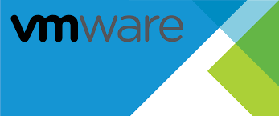](https://www.guru99.com/images/1/030119_1316_Top21CloudC5.png)

VMware is a comprehensive cloud management platform. It helps you to manage a hybrid environment running anything from traditional to container workloads. The tools also allow you to maximize the profits of your organization.

**Features:**

* Enterprise-ready Hybrid Cloud Management Platform
* Offers Private & Public Clouds
* Comprehensive reporting and analytics which improve the capacity of forecasting & planning
* Offers additional integrations with 3rd parties and custom applications, and tools.
* Provides flexible, Agile services

**Download link:** <https://www.vmware.com/in/cloud-services/infrastructure.html>

### 12) Salesforce

[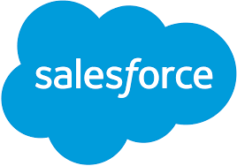](https://www.guru99.com/images/1/030119_1316_Top21CloudC7.png)

Salesforce cloud computing offers multiple cloud services like Sales Cloud, Service Cloud, Marketing Cloud, etc. Helps you to accelerate production of your environment.

**Features:**

* Salesforce Service Cloud offers 24 * 7 support
* Allows you to take a right and decisive decisions about your business
* Helps in managing the customer's contact information, automating the business processes, etc.

<https://www.salesforce.com/in/cloudcomputing/>

### 13) Oracle Cloud

[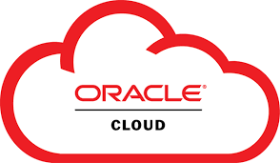](https://www.guru99.com/images/1/030119_1316_Top21CloudC8.png)

Oracle Cloud offers innovative and integrated cloud services. It helps you to build, deploy, and manage workloads in the cloud or on premises. Oracle Cloud also helps companies to transform their business and reduce complexity.

**Features:**

* Oracle offers more options for where and how you make your journey to the cloud
* Oracle helps you realize the importance of modern technologies including Artificial intelligence, chatbots, machine learning, and more
* Offers Next-generation mission-critical data management in the cloud
* Oracle provides better visibility to unsanctioned apps and protects against sophisticated cyber attacks

**Download link:** <https://www.oracle.com/cloud/>

### 14) Verizon Cloud

[](https://www.guru99.com/images/1/030119_1316_Top21CloudC9.png)

Verizon Cloud computing platform allows you to control your infrastructure with advanced set-up and customization options from a single user interface.

**Features:**

* Expand any workload quickly to help grow your business with less risk
* Helps you to build the right cloud with performance, support, and flexibility to make your business successful
* Allows you to select flexible service need according to your organizations
* You can trim down the risk and retain the data integrity across the apps

**Download link:** <http://www.verizonenterprise.com/welcome-to-verizon-cloud/>

### 15) Navisite

[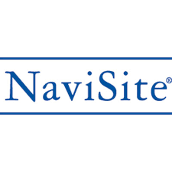](https://www.guru99.com/images/1/030119_1316_Top21CloudC10.png)

NaviSite provide cloud services for enterprises and mid-sized businesses by using the best IT technologies.

It offers a range of cloud service solutions like Cloud Infrastructure services, Cloud desktop, and hosting services.

**Features:**

* NaviSite simplifies application management services which include Managed Office 365 services
* It offers cloud-based Infrastructure-as-a-Service (IaaS) solutions that include managed cloud and self-service cloud solutions
* It helps you to simplify desktop management and administration

**Download link:**<https://www.navisite.com/>

### 16) IBM Cloud

[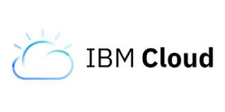](https://www.guru99.com/images/1/030119_1316_Top21CloudC11.png)

IBM cloud is a full stack cloud platform which spans public, private and hybrid environments. It is built with a robust suite of advanced and AI tools.

**Features:**

* IBM cloud offers infrastructure as a service (IaaS), software as a service (SaaS) and platform as a service (PaaS)
* IBM Cloud is used to build pioneering which helps you to gain value for your businesses
* It offers high performing cloud communications and services into your IT environment

**Download link:** <https://www.ibm.com/cloud/>

### 17) OpenNebula

[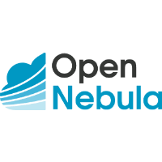](https://www.guru99.com/images/1/030119_1316_Top21CloudC12.png)

OpenNebula is a cloud computing platform. It allows you to manage heterogeneously distributed data center infrastructures. It helps you to manages the data center's virtual infrastructure to build private, public and hybrid implementations.

**Features:**

* Easy to install, use, maintain, and operate
* Provides greater functionality for private & hybrid clouds
* Highly-scalable, reliable, and commercially supported

**Download link:** <https://opennebula.org/>

### 18) Pivotal

[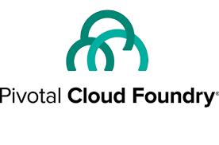](https://www.guru99.com/images/1/030119_1316_Top21CloudC13.png)

Pivotal cloud foundry which is shortly known as PCF is a proven digital solution for businesses. It helps you to move faster toward a software-driven future.

**Features:**

* Accelerate feature delivery
* Specially designed tool for zero-downtime deployments
* Helps you to reduce risk in your app portfolio
* Deliver enterprise SLAs (Service level agreement) at scale

**Download link:** <https://pivotal.io/>

### 19) CloudSigma

[](https://www.guru99.com/images/1/030119_1316_Top21CloudC15.png)

Cloudsigma is a flexible cloud server, and virtual private server hosting solutions. It offers a straightforward and transparent approach for pricing. You can easily stream at multiple gigabit speed from their cloud servers.

**Features:**

* Helps you to achieve complete control and flexibility over your cloud environment
* Allows you to mix & match all SSD and magnetic storage
* This cloud computing service tool is certified as compliant with the highest ISO 27001 requirements for security and data privacy

**Download link:** <https://www.cloudsigma.com/>

### 20) Dell Cloud

[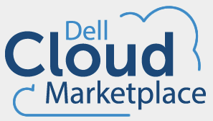](https://www.guru99.com/images/1/030119_1316_Top21CloudC16.png)

Dell offers a cloud platform, cloud-enabled infrastructure, models, and serves in a single place. It allows your own or selects from reference architecture, integrated and public cloud platforms.

**Features:**

* Cloud that works with your existing operations
* Cloud consumption using Dell Financial Services
* Accelerate your transformation with expert cloud services

**Download link:** [https://www.dellemc.com/en-us/cloud/hybrid-cloud computing/index.htm](https://www.dellemc.com/en-us/cloud/hybrid-cloud%20computing/index.htm)

### 21) LimeStone

[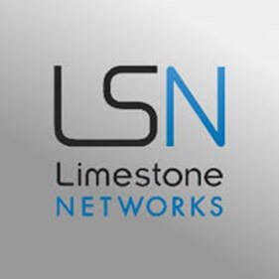](https://www.guru99.com/images/1/030119_1316_Top21CloudC18.jpg)

OnePortal Rapid is built with the latest open source technology to offer fast, feature rich, highly scalable cloud platform.

**Features:**

* Helps you to build and deploy applications with standard OpenStack based API libraries
* OpenStack Horizon web dashboard allows easy tracking and managing your cloud
* Flexible billing method ensures you only pay for the resources you use
* Scale quickly with additional compute and storage resource

**Download link:** <https://www.limestonenetworks.com/cloud/servers.html>

### 22) Quadranet:

[https://www.guru99.com/images/1/030119_1316_Top21CloudC201.png](https://www.guru99.com/images/1/030119_1316_Top21CloudC201.png)

If a cloud which was developed by Quadranet is fully scalable and reliable cloud infrastructure, the tool is billed hourly based on your line resource size which you can view a break down of the cost associated with each resource.

**Features:**

* QuadraNet's uptime SLA comes default with all cloud configurations
* The InfraCloud supports a wide variety of OS like CentOS to FreeBSD to Windows
* The custom interface helps you to manage your InfraCloud instances

**Download link:** <https://www.quadranet.com/infracloud>

## Tips for selecting a Cloud Service Provider

There "best" Cloud Service cannot be defined. You need to a chose a cloud service "best" for your project. Following checklist will help:

* Is your desired region supported?
* Cost for the service and your budget
* For an outsourcing company, Customer/Client Preference of service provider needs to be factored in
* Cost involved in training employees on the Cloud Service Platform
* Customer support
* The provider should have a successful track record of stability/uptime/reliability
* Reviews of the company

#### Here is a list of Top 21 Cloud Service Providers for Quick Reference

* Amazon Web Services
* Kamatera
* DigtialOcean
* Rackspace
* MassiveGrid
* Alibaba Cloud
* LiquidWeb
* Microsoft Azure
* Google Cloud Platform
* VMware
* Salesforce
* Oracle Cloud
* Verizon Cloud
* Navisite
* IBM Cloud
* OpenNebula
* Pivotal
* CloudSigma
* Dell Cloud
* LimeStone
* Quadranet

# Microsoft Azure Tutorial for Beginners: Learn in 1 Day

Before we learn Azure, let's understand

## What is Cloud Computing?

Cloud computing is a term referred to storing and accessing of data over the internet. It doesn't store any data on the hard disk of your personal computer. In cloud computing, you access data from a remote server.

## What is Microsoft Azure?

Azure is a cloud computing platform which was launched by Microsoft in February 2010. It is an open and flexible cloud platform which helps in development, data storage, service hosting, and service management. The Azure tool hosts web applications over the internet with the help of Microsoft data centers.

In this tutorial, you will learn:

* [What is Cloud Computing?](https://www.guru99.com/microsoft-azure-tutorial.html#1)
* [What is Microsoft Azure?](https://www.guru99.com/microsoft-azure-tutorial.html#2)
* [Types of Azure Clouds](https://www.guru99.com/microsoft-azure-tutorial.html#3)
* [Azure key Concepts](https://www.guru99.com/microsoft-azure-tutorial.html#4)
* [Azure Domains (Components)](https://www.guru99.com/microsoft-azure-tutorial.html#5)
* [Traditional vs. Azure Cloud Model](https://www.guru99.com/microsoft-azure-tutorial.html#6)
* [Applications of Azure](https://www.guru99.com/microsoft-azure-tutorial.html#7)
* [Advantages of Azure](https://www.guru99.com/microsoft-azure-tutorial.html#8)
* [DisAdvantages of Azure](https://www.guru99.com/microsoft-azure-tutorial.html#9)

## Types of Azure Clouds

There are mainly three types of clouds in Microsoft Azure are:

1. PAAS
2. SAAS
3. IASS

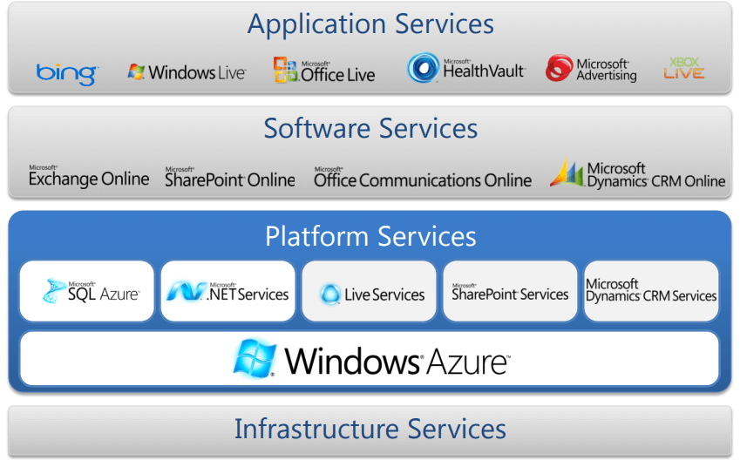

### Azure as IaaS

IaaS(Infrastructure as a Service) is the foundational cloud platform layer. This Azure service is used by IT administrators for processing, storage, networks or any other fundamental computer operations. It allows users to run arbitrary software.

**Advantages:**

* It offers efficient design time portability
* It is advisable for the application which needs complete control
* IaaS offers quick transition of services to clouds
* The apparent benefit of laaS is that it frees you from the concerns of setting up many physical or virtual machines.
* Helps you to access, monitor and manage datacenters

**Disadvantages of Iaas:**

* Plenty of security risks from unpatched servers
* Some companies have defined processes for testing and updating on-premise servers vulnerabilities. This cannot be done with Azure.

### Azure as PaaS

PaaS is a computing platform which includes an operating system, programming language execution environment, database or web services. This Azure service is used by developers and application providers.

As its name suggests, this platform is provided to the client to develop and deploy software. It allows the client to focus on application development instead of worrying about hardware and infrastructure. It also takes care of operating systems, networking and servers issues.

**Advantages:**

* The total cost is low as the resources are allocated on demand and servers are automatically added or subtracted.
* Azure is less vulnerable because servers are automatically checked for all known security issues
* The entire process is not visible to the developer, so it does not have a risk of a data breach

**Disadvantages:**

* Portability issues can occur when you use PaaS services
* There may be different environment at Azure, so the application needs to adapt accordingly.

### Azure As SaaS

SaaS (Software as a Service) is software which is centrally hosted and managed. It is a single version of the application is used for all customers. You can scale out to multiple instances. This helps you to ensure the best performance in all locations. The software is licensed through a monthly or annual subscription. MS Exchange, Office, Dynamics are offered as a SaaS

## Azure key Concepts

|  |  |
| --- | --- |
| **Concept Name** | **Description** |
| **Regions** | Azure is a global cloud platform which is available across various regions around the world. When you request a service, application, or VM in Azure, you are first asked to specify a region. The selected region represents datacenter where your application runs. |
| **Datacenter** | In Azure, you can deploy your applications into a variety of data centers around the globe. So, it is advisable to select a region which is closer to most of your customers. It helps you to reduce latency in network requests. |
| **Azure portal** | The Azure portal is a web-based application which can be used to create, manage and remove Azure resource and services. It is located at [https://portal.azure.com](https://portal.azure.com/). |
| **Resources** | Azure resource is an individual computer, networking data or app hosting services which charged individually. Some common resources are virtual machines( VM), storage account, or SQL databases. |
| **Resource groups** | An Azure resource group is a container which holds related resource for an Azure solution. It may include every resource or just resource which you wants to manage. |
| **Resource Manager templates** | It is a JSON which defines one or more resource to deploy to a resource group. It also establishes dependencies between deployed resources. |
| **Automation:** | Azure allows you to automate the process of creating, managing and deleting resource by using PowerShell or the Azure command-line Interface(CLI). |
| **Azure PowerShell** | PowerShell is a set of modules that offer cmdlets to manage Azure. In most cases, you are allowed to use, the cmdlets command for the same tasks which you are performing in the Azure portal. |
| **Azure command-line interface(CLI)** | The Azure CLI is a tool that you can use to create, manage, and remove Azure resources from the command line. |
| **REST APIs** | Azure is built on a set of REST APIs help you perform the same operation that you do in Azure portal Ul. It allows your Azure resources and apps to be manipulated via any third party software application. |

## Azure Domains (Components)

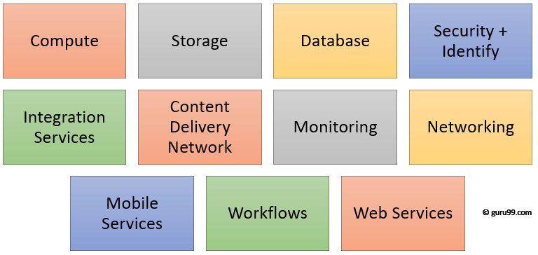

Key Azure Components

### Compute

It offers computing operations like app hosting, development, and deployment in Azure Platform. It has the following components:

* Virtual Machine: Allows you to deploy any language, workload in any operating system
* Virtual Machine Scale Sets: Allows you to create thousands of similar virtual machines in minutes
* Azure Container Service: Create a container hosting solution which is optimized for Azure. You scale and arrange applications using Kube, DC/OS, Swarm or Docker
* Azure Container Registry: This service store and manage container images across all types of Azure deployments
* Functions: Let's you write code regardless of infrastructure and provisioning of servers. In the situation when your functions call rate scales up.
* Batch: Batch processing helps you scale to tens, hundreds or thousands of virtual machines and execute computer pipelines.
* Service Fabric: Simplify microservice-based application development and lifecycle management. It supports Java, PHP, Node.js, Python, and Ruby.

### Storage

Azure store is a cloud storage solution for modern applications. It is designed to meet the needs of their customer's demand for scalability. It allows you to store and process hundreds of terabytes of data. It has the following components:

* Blob Storage: Azure Blob storage is a service which stores unstructured data in the cloud as objects/blobs. You can store any type of text or binary data, such as a document, media file, or application installer.
* Queue Storage: It provides cloud messaging between application components. It delivers asynchronous messaging to establish communication between application components.
* File Storage: Using Azure File storage, you can migrate legacy applications. It relies on file shares to Azure quickly and without costly rewrites.
* Table Storage: Azure Table storage stores semi-structured NoSQL data in the cloud. It provides a key/attribute store with a schema-less design

### Database

This category includes Database as a Service (DBaaS) which offers SQL and NoSQL tools. It also includes databases like Azure Cosmos DB and Azure Database for PostgreSQL. It has the following components:

* SQL Database: It is a relational database service in the Microsoft cloud based on the market-leading Microsoft SQL Server engine.
* DocumentDB: It is a fully managed NoSQL database service which is It built for fast and predictable performance and ease of development.
* Redis Cache: It is a secure and highly advanced key-value store. It stores data structures like strings, hashes, lists, etc.

### Content Delivery Network

Content Delivery Network (CDN) caches static web content at strategically placed locations. This helps you to offer speed for delivering content to users. It has the following components:

* VPN Gateway: VPN Gateway sends encrypted traffic across a public connection.
* Traffic Manager: It helps you to control and allows you to do the distribution of user traffic for services like WebApps, VM, Azure, and cloud services in different Datacenters
* Express Route: Helps you to extend your on-premises networks into the Microsoft cloud over a dedicated private connection to Microsoft Azure, Office 365, and CRM Online.

### Security + Identify sevices

It provides capabilities to identify and respond to cloud security threats. It also helps you to manage encryption keys and other sensitive assets. It has the following components:

* Key Vault: Azure Key Vault allows you to safeguard cryptographic keys and helps you to create secrets used by cloud applications and services.
* Azure Active Directory: Azure Active Directory and identity management service. This includes multi-factor authentication, device registration, etc.
* Azure AD B2C: Azure AD B2C is a cloud identity management solution for your consumer-facing web and mobile applications. It allows you to scales hundreds of millions of consumer identities.

### Enterprise Integration Services:

* Service Bus: Service Bus is an information delivery service which works on the third-party communication system.
* SQL Server Stretch Database: This service helps you migrates any cold data securely and transparently to the Microsoft Azure cloud
* Azure AD Domain Services: It offers managed domain services like domain join, group policy, LDAP, etc. This authentication which is compatible with Windows Server Active Directory.
* Multi-Factor Authentication: Azure Multi-Factor Authentication (MFA) is two-step verification. It helps you to access data and applications to offers a simple sign-in process.

### Monitoring + Management Services

These services allow easy management of Azure deployment.

* Azure Resource Manager: It makes it easy for you to manage and visualize resource in your app. You can even control who is your organization can act on the resources.
* Automation: Microsoft Azure Automation is a way to automate the manual, long-running, error-free, and constantly repeated tasks. These tasks are commonly performed in a cloud and enterprise environment.

### Azure Networking

* Virtual Network: Perform Network isolation and segmentation. It offers filter and Route network traffic.
* Load Balancer: Offers high availability and network performance of any application. Load balance information Internet traffic to Virtual machines.
* Application Gateway: It is a dedicated virtual appliance that offers an Application Delivery Controller (ADC) as a service.
* Azure DNS: Azure DNS hosting service offers name resolution using Microsoft Azure infrastructure.

### Web and Mobile Services:

* Web Apps: Web Apps allows you to build and host websites in the programming language of your choice without the need to manage its infrastructure.
* Mobile Apps: Mobile Apps Service offers a highly scalable, globally available mobile app development platform for users.
* API Apps: API apps make it easier to develop, host and consume APIs in the cloud and on-premises.
* Logic Apps: Logic Apps helps you to simplify and implement scalable integrations

### Workflows in the cloud

It provides a visual designer to create and automate your process as a series of steps known as a workflow

* Notification Hubs: Azure Notification Hubs offers an easy-to-use, multi-platform, scaled-out push engine
* Event Hubs: Azure Event Hubs is data streaming platform which can manage millions of events per second. Data sent to an event hub can be transformed and stored using any real-time analytics offers batching/storage adapters.
* Azure Search: It is a cloud search-as-a-service solution which offers server and infrastructure management. It offers ready-to-use service that you can populate with your data. This can be used to add search to your web or mobile application.

### Migration

Migration tools help an organization estimate workload migration costs. It also helps to perform the migration of workloads from your local data centers to the Azure cloud.

## Traditional vs. Azure Cloud Model

|  |  |
| --- | --- |
| **Traditional** | **Azure Cloud Model** |
| Dedicated infrastructure for each application | Loosely coupled apps and micro-services |
| Purpose-built hardware | Industry-standard hardware |
| Distinct infrastructure and operations teams | Service-focused DevOps teams |
| Customized processes & configurations | Standardized processes & configurations |

## Applications of Azure

Microsoft Azure is used in a broad spectrum of applications like:

* Infrastructure Services
* Mobile Apps
* Web Applications
* Cloud Services
* Storage, Backup, and Recovery
* Data Management
* Media Services

## Advantages of Azure

Here, are advantages of using Azure:

* Azure infrastructure will cost-effectively enhance your business continuity strategy
* It allows you to access the application without buying a license for the individual machine
* Windows Azure offers the best solution for your data needs, from SQL database to blobs to tables
* Offers scalability, flexibility, and cost-effectiveness
* Helps you to maintain consistency across clouds with familiar tools and resources
* Allows you to extend data center with a consistent management toolset and familiar development and identity solutions.
* You can deploy premium virtual machines in minutes which also include Linux and Windows servers
* Helps you to scale your IT resources up and down based on your needs
* You are not required to run the high-powered and high-priced computer to run cloud computing's web-based applications.
* You will not require processing power or hard disk space if you are using Azure
* Cloud computing offers virtually limitless storage
* If your personal computer or laptop crashes, all your data is still out there in the cloud, and it is still accessible
* Sharing documents leads directly to better collaboration
* If you change your device your computers, applications and documents follow you through the cloud

## DisAdvantages of Azure

* Cloud computing is not possible if you can't connect to the Internet
* Azure is a web-based application which requires a lot of bandwidth to download, as do large documents
* Web-based applications can sometimes be slower compared to accessing a similar software program on your desktop PC

## Summary

* Cloud computing is a term referred to storing and accessing of data over the internet
* Azure is a cloud computing platform which was launched by Microsoft in February 2010
* There are mainly three types of clouds in Microsoft Azure: 1)PAAS 2) SAAS 3) IASS
* IaaS(Infrastructure as a Service) is the foundational cloud platform layer.
* PaaS is a computing platform which includes an operating system, programming language execution environment, database or web services
* SaaS (Software as a Service) is software which is centrally hosted and managed.
* Datacentres and regions, Azure portal, Resources, Resource groups, Resource Manager templates, Azure PowerShell, Azure command-line interface(CLI) are some of the key terms used in Azure
* Important components of Microsoft Azure are Compute, Storage, Database, Monitoring & management services, Content Delivery Network, Azure Networking, Web & Mobile services, etc.
* Traditional model used purpose-built hardware while Azure cloud model uses Industry-standard hardware
* Important applications of Microsoft Azure are: Infrastructure Services, Mobile Apps, Web Applications, Cloud Services, Storage, Backup, and Recovery, Data Management, and Media Services
* The biggest advantage of Microsoft Azure infrastructure is that it will cost-effectively enhance your business continuity strategy
* Web-based applications like Azure can sometimes be slower compared to accessing a similar software program on your desktop PC

# 16 BEST Free Cloud Storage (2019 Update)

Cloud storage is a way of storing data online. It requires an internet connection in order to maintain, manage, and share documents, presentations, spreadsheets, images, audio, video, etc. with others. Online storage service providers don't store any data on the hard disk of your PC. Cloud storage tools help you to access your data from any device.

Following is a handpicked list of top cloud storage tools, with popular features and latest download links.

### 1) Google Drive

[](https://www.guru99.com/images/1/090719_0515_16BESTFreeC1.png)

Google Drive is a free online data storage service provided by Google. The service syncs stored files, photos, and more across all the user's PCs, tablets, and mobile devices. It offers 15 GB of free space.

**Features:**

* You can build Docs, Sheets, Slides.
* It provides real time synchronization.
* You can create forms that help you to run a survey.
* The tool can be used for macOS.
* Integrates with thousands of external apps like a mind map, Gantt chart, diagram tools, etc.
* It allows to store documents up to 1.02 million characters, spreadsheets up to 5 million cells, presentation up to 100 MB, and Google Sites up to 2000,000 characters per page.

**Download Link:** <https://www.google.com/drive/>

### 2) Box

[](https://www.guru99.com/images/1/090719_0515_16BESTFreeC2.png)

Box is a cloud file management and sharing service. This tool is available for Windows, macOS, and mobile platforms.

**Features:**

* You can use Windows Explorer or Mac Finder to quickly search the file you want.
* Edit like a local file and Box will save it to the cloud.
* Allows you to invite the team to make changes and upload files.
* Enable admin to add external users to collaborate content and control the version.

**Download Link:** <https://www.box.com/en-gb/drive>

### 3) OneDrive

[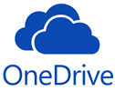](https://www.guru99.com/images/1/090719_0515_16BESTFreeC3.png)

Microsoft OneDrive is an internet-based storage and synchronization service provider. It is available for free to all the people having Microsoft account. OneDrive apps can be used to sync files on a Windows PC or Mac operating system.

**Features:**

* Use your phone to scan and business cards, receipts, whiteboard notes, or store paper documents in OneDrive.
* You can set an expiration date of shared files, photos, and links for security purpose.
* Allows uploading files up to 15 GB in size.

**Download Link:** <https://onedrive.live.com/about/en-in/>

### 4) Mega

[](https://www.guru99.com/images/1/090719_0515_16BESTFreeC4.png)

Mega is an online storage and file hosting service provided by Mega Limited. Mega is available for Windows, Mac, and Linux platform.

**Features:**

* It offers 50 GB free storage space.
* It uses keys to encrypt files and chats.
* Mega allows you to sync files and folders.
* Upload or download 1 GB data every 6 hours

**Download Link:** <https://mega.nz/>

### 5) Yandex Disk

[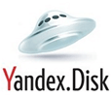](https://www.guru99.com/images/1/090719_0515_16BESTFreeC5.png)

Yandex Disk is a cloud service that allows users to store files on cloud servers and share with others. Disk is available on Windows, macOS as well as Linux. It is available in two plans Annual and Monthly subscription.

`**Features:**

* Allows uploading maximum 50 GB file size. User can sync data between different devices.
* Provides free access to Microsoft Word, Excel, and PowerPoint.
* Offer you to download files from public pages without any hassle.

**Download Link:** <https://disk.yandex.com/>

### 6) Upthere

[](https://www.guru99.com/images/1/090719_0515_16BESTFreeC6.png)

Upthere offer you to store videos, photos, music, and documents safely and privately in the cloud. This platform is based on UpOS technology to store, manage, share data. Upthere is available for iPhone, Android, Mac, and Windows.

**Features:**

* Share any number of files without any size limitation.
* It enables you to create privately shared loops for celebrations, trips, or whatever works good for you.
* Anyone can invite other people, add content, and comment.

**Download Link:** <https://upthere.com/>

### 7) Media Fire

[](https://www.guru99.com/images/1/090719_0515_16BESTFreeC7.png)

MediaFire is a file hosting, cloud storage, and synchronization service. It provides an easy-to-use solution for managing digital stuff online as well as on the go. MediaFire can be used for iPhone, Windows, OSX, Web, and Android.

**Features:**

* Maximum file uploading limit is 20 GB
* It offers the professional an ad-free experience to employees.
* Lets you to paste link in any files and MediaFire will upload to your account
* Allows you to specify access control.

**Download Link:** <https://www.mediafire.com/>

### 8) Koofr

[](https://www.guru99.com/images/1/090719_0515_16BESTFreeC8.png)

Koofr is a cloud storage solution that connects Dropbox, Amazon, Google Drive, OneDrive accounts and utilizes the additional free space on a hard drive. The tool is available for Android, iOS, Windows, Linux, Windows, and macOS.

**Features:**

* Automatic backup from phones.
* Synchronization data with computers.
* No file type and size limits, upload anything you want to keep safe.
* It provides automatic backup of photos and videos from the mobile phone.

**Download Link:** <https://koofr.eu/>

### 9) Icedrive

[](https://www.guru99.com/images/1/090719_0515_16BESTFreeC9.jpg)

Icedrive is the next generation cloud service that helps you to access, manage, and update your cloud storage effortlessly. It provides a space to share, showcase, and collaborate with your files.

**Features:**

* It allows you to store files up to 100 TB.
* Sync all your data from the computer.
* Icedrive provides clean and easy to use interface to manage your files.

**Download Link:** <https://icedrive.net/>

### 10) MiMedia

[](https://www.guru99.com/images/1/090719_0515_16BESTFreeC10.png)

MiMedia is a cloud-based backup service that allows you to manage and enjoy your digital life. It helps you to curate your personalized collection.

**Features:**

* It allows you to access and organize music, photos, videos, and documents on all devices.
* You can download a desktop app to your PC or Mac and put any content in the cloud.
* Import from Dropbox, Google, Flickr, and Facebook.

**Download Link:** [http://www.mimedia.com](http://www.mimedia.com/)

### 11) IDrive

[](https://www.guru99.com/images/1/090719_0515_16BESTFreeC11.png)

IDrive provides service for data backup. This service is available to Windows, Linux, iOS, Android, and Mac users.

**Features:**

* IDrive provides 5 GB free
* Users can organize and monitor backups of their PC from the web interface.
* Users can upload or download files up to 2 GB in size.
* It provides the best solution to protect all computers, Macs, iPhones, and Android devices into one account.

**Download Link:** <https://www.idrive.com/>

### 12) ICloud

[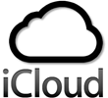](https://www.guru99.com/images/1/090719_0515_16BESTFreeC12.png)

ICloud is a cloud storage service managed by Apple Inc.

It is a service where users can save any files on the cloud, and iCloud will automatically sync to your device. You can use this service for Mac and Windows PCs.

**eatures:**

* It provides 5GB of free iCloud storage
* File size uploading limit is 15 GB.
* Many people can work together by simply sending a link.
* Lets you to collaborate with numbers, Keynote, Pages, and Notes.

**Download Link:** <https://www.apple.com/in/icloud/>

### 13) Amazon Drive

[](https://www.guru99.com/images/1/090719_0515_16BESTFreeC13.png)

Amazon Drive or Amazon Cloud Drive is a cloud storage application of Amazon. The service provides secure cloud storage, file sharing, photo printing, and file backup.

**Features:**

* It helps you to organize and edit photos online.
* Amazon Drive automatically backs up the photos and videos on your phone.
* Allows you to Sync files and folders.

**Download Link:**<https://www.amazon.com/b?ie=UTF8&node=15547130011>

### 14) Sync

[](https://www.guru99.com/images/1/090719_0515_16BESTFreeC14.png)

[Sync.com](http://sync.com/) is a cloud service for sharing files from any computer or mobile device. Sync provides an ideal solution for storing and sharing confidential and sensitive data.

**Features:**

* Sync allows you to send files of any size to anyone, even if they don't have a registered.
* Performance becomes slower if you upload files larger than 40 GB.
* Synch can support Windows, Mac, iOS, and Android.
* It gives unlimited data transfer for all the plans.

**Download Link:** <https://www.sync.com/>

### 15) Dropbox

[](https://www.guru99.com/images/1/090719_0515_16BESTFreeC15.png)

Dropbox is a file hosting service providing personal cloud, file synchronization, cloud storage, and client software. It is designed to collaborate your projects whether you are working alone or in a team.

**Features:**

* It offers you to safely sync data across all devices.
* Your file size should be 50 GB or smaller
* Service is available for macOS, Linux, and Windows operating systems.

**Download Link:** <https://www.dropbox.com/>

### 16) Jumpshare

[](https://www.guru99.com/images/1/090719_0515_16BESTFreeC16.png)

Jumpshare combines screenshot capture, file sharing, video recording, as well as team collaboration. It allows you to to send and share unlimited big size file.

**Features:**

* It helps you to capture and share anything
* Jumpshare has drag and drop facility to share any file.
* Allows you to capture screenshots
* You can record your screen in GIF or video.
* This service can be used on macOS, Android, Windows, iPad, and iPhone.

**Download Link:** <https://jumpshare.com/>

Here is a summary of the cloud storage providers

|  |  |  |
| --- | --- | --- |
| **Name** | **Link** | **Free Space** |
| Google Drive | <https://www.google.com/drive/> | 15GB |
| Box | <https://www.box.com/en-gb/drive> | 10GB |
| OneDrive | <https://www.pcloud.com/> | 5GB |
| Mega | <https://mega.nz/> | 50GB |
| Yandex Disk | <https://disk.yandex.com/> | 50GB |
| Upthere | <https://upthere.com/> | 20GB |
| Media Fire | <https://www.mediafire.com/> | 10GB |
| Koofr | <https://koofr.eu/> | 10GB |
| Ice Drive | <https://icedrive.net/> | 10GB |
| MiMedia | [http://www.mimedia.com](http://www.mimedia.com/) | 10GB |
| IDrive | <https://www.idrive.com/> | 5GB |
| iCloud | <https://www.apple.com/in/icloud/> | 5GB |
| Amazon Drive | <https://www.amazon.com/b?ie=UTF8&node=15547130011> | 5GB |
| Sync | <https://www.sync.com/> | 5GB |
| Dropbox | <https://www.dropbox.com/> | 2GB |
| Jumpshare | <https://jumpshare.com/> | 2GB |